Time to act: exploration and exploitation of time-dependent instrumental contingencies

A time to plant,  
    And a time to pluck *what is* planted;

…

A time to gain,  
    And a time to lose;  
A time to keep,  
    And a time to throw away;

Ecclesiastes 4

Timing decides the success of our actions, be it hunting, negotiations (Sinaceur and Neale 2005), courtship, or humor. Optimal timing is often not known *a priori*, but learned from experience. Such learning may involve a representation of a partially observed time-dependent process, such as movement of prey or another person’s internal state. To the extent that such a process determines success – or expected reward – it constitutes a *time-dependent contingency.*  This white paper considers theoretical and computational problems encountered by agents that learn and exploit such contingencies. We present a reinforcement learning model that attempts to solve some of these problems, building on existing models of associative learning.

# Time-dependent contingencies in Pavlovian conditioning: temporal difference model

The way animals represent time-dependent contingencies has been studied in some detail under Pavlovian (stimulus-reward) conditioning (Fiorillo, Newsome, & Schultz, 2008)(Fiorillo, Tobler, & Schultz, 2003)(Ludvig, Sutton, & Kehoe, 2008, 2012). In classical conditioning, an organism learns to predict the likelihood of a biologically salient outcome or reward (i.e., the unconditioned stimulus, US) on the basis of neutral stimuli that precede the outcome (i.e., conditioned stimuli, CS). Behaviorally, the organism’s reward expectation is revealed by a conditioned response (CR) such as licking or sucking. The CR and dopamine signals that presumably underlie learning (Schultz, Dayan, & Montague, 1997) have been argued to be relatively temporally imprecise (Fiorillo et al., 2008)(Fiorillo et al., 2003).

Temporal difference (TD) models of Pavlovian conditioning have long incorporated continuous-time representations of CS-US relationships. TD places time at the center of the associative process, theorizing that organisms use information about the time between predictive events (stimuli, actions) and receipt of rewards to make a temporally precise reward prediction. “Temporal difference” refers to the difference between current reward prediction and the reward prediction at the preceding moment in time (sometimes discretized as time steps). During learning, TD representation is updated based on *prediction error* – the discrepancy between TD and actual reward at a given time step (Sutton & Barto, 1998). In its simplest form, TD estimates future rewards by repeating the following algorithm in each learning episode (time step):

*Vt+1* 🡨 *Vt + αδt*

*δt = rt+1+γVt+1-Vt*

where V is expected reward value, γ is the discount rate reflecting a preference for immediate over delayed rewards, α is the learning rate and δ expressed more intuitively as rt+1 – (Vt - γVt+1) is the prediction error (PE). Thus, when the actual reward exceeds the magnitude of change in reward prediction Vt - γVt+1, a positive PE results, and vice versa.

To ensure that more closely preceding (eligible) stimuli receive more credit for a subsequent reward, an extension known as TD(λ) uses memory variables termed *eligibility traces*. At each time step the eligibility trace *e* for a given stimulus decays by γλ, where λ is the temporal generalization parameter:

*et+1* = γλ*et*.

Thus the value of past stimuli is updated based on their temporal proximity:

*Vt+1 = Vt + αδtet*

How exactly does an animal represent the temporal occurrence of a stimulus? The simplest version is *presence,* where the stimulus is captured by a single element that is on when the stimulus is on (Fig. X). The presence representation ignores obvious differences between various time points of the stimulus such as the beginning and end, which are salient for the animal. At another extreme is the *complete serial compound* representation (Fig. X), where each time point of the stimulus receives its own delay line, as if each moment in time were tracked as a separate event. Ludvig and colleagues demonstrated the advantage of representing a stimulus as an exponentially decaying series of broadening *microstimuli* over straightforward schemes such as presence and complete serial compound, Fig. X, (Ludvig et al., 2012). Conceptually, microstimuli are neuron-like elements with temporal receptive fields. In this representation, a memory trace decays exponentially:

*yt = dyt-1,* where d is a decay factor.

The stimulus is further coarsely coded by a basis function consisting of a series of Gaussian microstimuli. These microstimuli have diminishing heights yt , centers that are increasingly farther apart (sparser) with time and with increasing widths (Fig. X). These features result in diminishing sensitivity toward the end of a time interval. Thus the basis function is defined as follows:

f (y, µ, σ) = (1/√2π)*exp(−[y − µ]2/2σ2),

Then, the level of *i*th microstimulus at time *t* is given by the product of trace height and the basis function:

*xt(i) = f (yt,i/m, σ)yt,*

where *x* is microstimulus height, *y* is memory trace, *m* is the number of microstimuli, and *σ* is the width parameter.

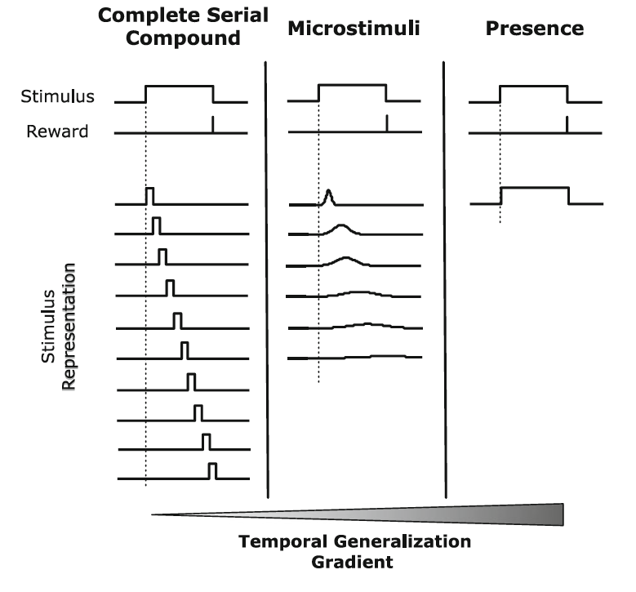

Fig. X, from Ludvig, Sutton & Kelsoe, 2012

Microstimulus representation has been successful in a number of Pavlovian conditioning scenarios (Ludvig et al., 2012). However, the ability of TD models to explain temporal features of CR and dopamine signals such as ramping (Fiorillo et al., 2008, 2003), regardless of stimulus representation, remains the subject of debate. Another challenge to existing TD models is interval adaptation. Fiorillo and colleagues have found that the precision of timing in midbrain dopamine neurons scales with the mean CS-US interval (learned over hundreds of trials), declining as intervals increase (Fiorillo et al., 2008).

# Instrumental conditioning: failures of TD and possible solutions

In contrast to the insights into the time-dependent associative representations during Pavlovian conditioning, the formal models of time-dependent representations governing instrumental (action-reward) conditioning remain less well developed. Instrumental contingencies present several additional challenges for a reinforcement learning model. First, the agent selects a temporally precise action instead of a temporally imprecise CR (Fiorillo et al., 2008, 2003). Thus, the model’s *policy representation* needs to precisely reflect various actions available at each time point. Next, while stimulus-reward Pavlovian contingencies are experienced passively, an instrumental agent has to actively *explore* available actions at various time points to uncover an action-reward contingency. Finally, inaction or waiting incurs an *opportunity cost*, which a model should aim to minimize. These challenges are illustrated by two human experiments: the Clock Task (Moustafa, Cohen, Sherman, & Frank, 2008) and the Willingness to Wait Task (McGuire & Kable, 2012). As outlined in our brief review below, significant progress has been made in modeling *strategic exploration* of time-dependent contingencies (Badre, Doll, Long, & Frank, 2012). However, no model solutions to the problems of temporal *policy representation* and *opportunity cost* remain elusive. Against this backdrop, we developed a new model of exploration and exploitation of time-dependent instrumental contingencies.

[An additional consideration in conceptualizing time-varying instrumental learning is whether the environment approximates a free operant paradigm in which the agent is able to make a series of choices that are reinforced probabilistically over a fixed amount time compared to an environment in which a fixed number of trials of finite length (e.g., 4 seconds) occur and the agent makes a single response for each trial. In the former case, opportunity cost may play a more significant role because waiting longer to emit a single response may result in a smaller cumulative gain than emitting several quick responses. Said differently, in free operant environments where reward contingencies vary in time, the agent’s goal is to learn how to maximize total reward over the entire experimental session (e.g., 10 minutes), not how to maximize the magnitude of each individual outcome.]

Example 1: Clock task

The first example of an instrumental task in which the action-reward contingency varies in time is drawn from the work of Michael Frank and colleagues who initially focused on the ability of patients with Parkinson’s disease to learn to speed or slow response times on the basis of time-varying instrumental feedback (Moustafa et al., 2008). In our adaptation of the clock task, for each trial participants view a ball that revolves around a central stimulus over the course of 4 seconds. Participants can press a button at any time to stop the ball’s rotation to receive a probabilistic reward depending on the time of their response. The time-varying reward schedule is consistent within each block of 50 trials and is derived from functions that are monotonically increasing, decreasing, or flat. In the increasing condition (IEV), the expected reward increases with time such that it is optimal to wait as long as possible to press the button. In the decreasing condition (DEV), by comparison, faster responses are associated with higher expected rewards. There are two constant expected value conditions (CEV and CEVR) in which



**Figure X. Schematic of clock paradigm**

To date, Frank and colleagues have published several papers that extend this paradigm to characterize response time adaptation in Parkinson’s disease (Moustafa et al., 2008), the role of dopamine in exploratory behavior (Frank, Doll, Oas-Terpstra, & Moreno, 2009), and the neural basis of uncertainty-driven exploration (Badre et al., 2012). Each of these studies has extended a computational model of response times on the task that builds upon earlier models of basal ganglia function (Frank, Seeberger, & O’Reilly, 2004). More specifically, the time-clock (TC) model of Frank and colleagues seeks to model trialwise response times as a linear combination of several putative neural processes:



where *t* is the trial number (not time within trial), *K* reflects baseline motor speed (conceptually related to the intercept term in multiple regression), $λRT(t-1)$ reflects the degree of autocorrelation between the current and previous trials, and $ν[RT_{best}-RT_{avg}]$ reflects the tendency to modulate reaction times toward the best payoff received so far in the learning episode (i.e., “go for the gold”). The Go term reflects the notion that response time is expected to decrease (i.e., speed up) on the trial following a positive prediction error, whereas the NoGo term reflects an expected increase in response time after a negative prediction error. These are hypothesized to operate through different basal ganglia pathways, Go via D1 receptors in the nigrostriatal pathway and NoGo via D2 receptors in the striatopallidal pathway.



Here, $α_{G}$ represents the learning rate for positive prediction errors and $α_{N}$ is the learning rate for negative prediction errors.

One of the key insights of the TC model is the notion that agents may track the value statistics of different response options as a function of time. The TC model makes a simplifying assumption that individuals may track information about the probability of a positive prediction error (PPE) separately for fast versus slow responses within the 4-second trial window. Although fast and slow responses can be defined in several ways, for illustration consider that in a 4-second trial, responses between zero and two seconds are fast whereas those between two and four seconds are slow. The TC model represents the probability of PPEs for fast and slow responses using two beta distributions, the conjugate prior for a binomial process (i.e., the occurrence/non-occurrence of a PPE). The expected probability of a PPE for a slow response is estimated as the mean of the beta distribution for slow responses on a given trial, $μ_{slow}(t)$, and likewise for probability of a PPE for fast responses, $μ_{fast}\left(t\right)$. The shapes of these distributions are updated via their shape parameters, $α$ and $β$ according to Bayes’ rule. For example, if a PPE occurs for a fast response on trial *t*, $α$ is incremented by 1: $α\left(t\right)= α\left(t-1\right)+1$, whereas if a negative prediction error occurs on trial *t*, $β$ is incremented by 1: $β\left(t\right)= β\left(t-1\right)+ 1$. This follows from the fact that the mean of a beta distribution is proportional to the ratio of alpha and beta:



Thus, by tracking the expected return for slow versus fast responses, the TC model is able to capture how response time modulates in proportion to differential expectations of fast and slow responses:



where $ρ$ is a free parameter that governs the degree of modulation to learned value of slow and fast responses.

A key innovation of the TC model is its representation of how uncertainty about slow versus fast responses governs response selection. The use of beta distributions for tracking the differential value of fast and slow responses also allows one to quantify uncertainty about the occurrence of PPEs using the second moment of the beta distribution, the variance. By initializing the fast and slow beta distributions with relatively flat probability priors, one can capture how sequential sampling reduces uncertainty about expected payoffs. Said differently, as one samples an increasing number of outcomes to fast responses, uncertainty about the probability of a PPE diminishes, and the standard deviation of the fast beta distribution, $σ_{fast}$, quantifies the degree of this uncertainty. Moreover, having separate distributions for fast and slow value statistics allows one to represent both differences in expected return (i.e., differences in the means of the distributions, as above) and differences in uncertainty about expected returns. For example, if one responds quickly for ten trials and slowly on the eleventh trial, much more is known about the probability of PPEs for fast than slow responses because of the disproportionate sampling.

An agent who is motivated to know the value of different actions may use information about relative uncertainty to guide his behavior. For example, an agent who has sampled reward outcomes of slow responses 10 times but fast responses only once may shift to fast responses in order to develop a more accurate representation of their value. This notion has been called uncertainty-driven or strategic exploration and has been linked with activity in the rostrolateral prefrontal cortex (Badre et al., 2012). In the TC model, uncertainty-driven exploration is defined by shifts in response time in proportion to the relative uncertainty about slow versus fast responses:



where $ε$ is a free parameter that captures individual differences in the modulation of response times according to relative uncertainty.

*Limitations of the TC model*

The TC model is an outstanding initial effort to represent decision processes in time-varying instrumental environments. In particular, the operationalization of uncertainty-driven exploration according to relative uncertainty offers new insights into the classical exploration-exploitation dilemma in reinforcement learning (Cohen, McClure, & Yu, 2007). That said, some important limitations of this model limit its generalizability to other time-varying instrumental problems.

First, by dividing the temporal space in half, the TC model provides a relatively coarse representation of the time-varying contingency. This heuristic approach to value representation adequately captures most monotonic reward functions such as those described above, but fails to represent other functions such as the quadratic function depicted below:

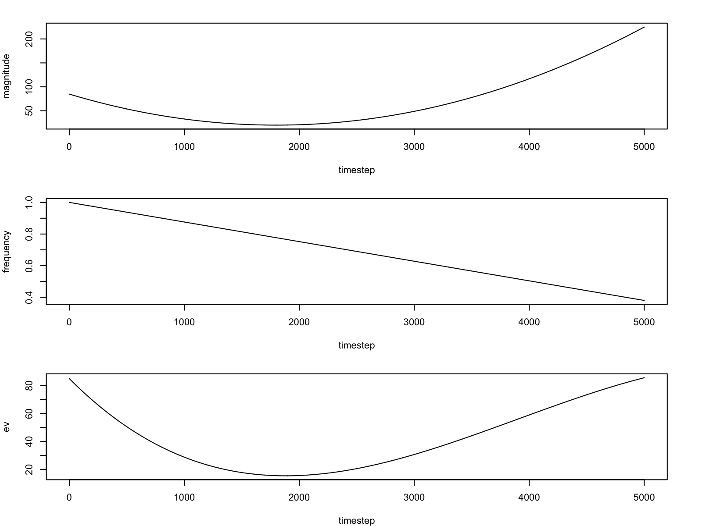Here, responses very early in time or very late in time are optimal, but responses in the middle of the time interval have a low expected value. Representing the value of early versus late responses would provide little information to guide response selection given that these values would be relatively similar. Other non-monotonic functions are also poorly represented by the TC model, such as a function with a periodic payoff (e.g., sinusoid).

Likewise, the slow/fast representation of relative uncertainty provides only coarse information about how to modulate response times to learn more about the contingency. From an information-theoretic standpoint, in sequential sampling, the greatest incremental information about the contingency would be obtained by choosing the response time about which one knows the least. In a fast/slow representation, uncertainty-driven exploration may lead one to sample heavily from 1–2 seconds while knowing relatively little about 0–1 seconds.

The central point is that in order to capture behavior on a broader class of time-varying instrumental problems, computational models that have a more nuanced representation of time are needed. Representing time-varying instrumental contingencies and corresponding uncertainty about response options is a kind of function approximation problem in which the agent needs to develop a reasonable approximation of the reward function by choosing maximally informative responses and learning from the outcomes. We take on this challenge in the section below.

An additional concern about the TC model is that the contributions of the free parameters representing decision processes are summed to generate a predicted response time on each trial.

1. Additive effects (absorb misfit)
2. Only captures monotonic contingencies
3. Coarse representation of time and uncertainty-driven exploration

* Example: Clock – MH
* Frank’s model -- MH
  + +Uncertainty-driven exploration
  + –Limited representation
    - Value: can only get monotonic contingencies
    - Uncertainty: unable to pick a region of maximum uncertainty
  + -RTbest
  + – additive model combining learning & choice rule

Temporal basis

* Temporal representation of value, time as a high-dimensional action space – Ludvig, Kelsoe & Sutton (good but does not extend to instrumental paradigms – Moustafa 2008, propagation) – MH
* No decay to reflect interval adaptation

Model [for now paste the equations]

* Temporal basis representation of ACTION value, not the same as state value in TD
* Temporal basis for uncertainty – predicts where precisely one will explore
* Opportunity cost based on reward rate
* Value-uncertainty competition

The

Value representation:



Uncertainty representation:



Choice rule:







Opportunity cost

*Time is the most valuable thing a man can spend.*

*Theophrastus*

Learning a temporal contingency does not yet guarantee optimal timing. One needs to also consider the intrinsic value of time. This value, usually termed *opportunity cost*, reflects alternative rewards that are foregone while waiting or performing an action. A good estimate of the opportunity cost is given by the long-term reward rate (Niv, Daw, & Dayan, 2005). Accordingly, in free operant experiments, higher reward rates induce higher response rates, a phenomenon termed *response vigor*. That is, in a richer environment, the animal acts sooner because the cost of inaction – the opportunity cost – is higher. Traditional models of animal learning such as Bush-Mosteller, Rescorla-Wagner (Bush & Mosteller, 1951; Rescorla & Wagner, 1972; Sutton & Barto, 1998) do not address the problem of the opportunity cost, nor does the real-time TD(λ) (Niv et al., 2005).

We estimate the reward rate simple

Temporal basis

*The only reason for time is so that everything doesn't happen at once.*

*Albert Einstein*